Naveen Bonala Git & GitHub

1)Install git.

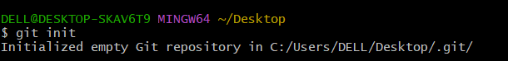

2)Create a repo in github with README.md and .ignore file.

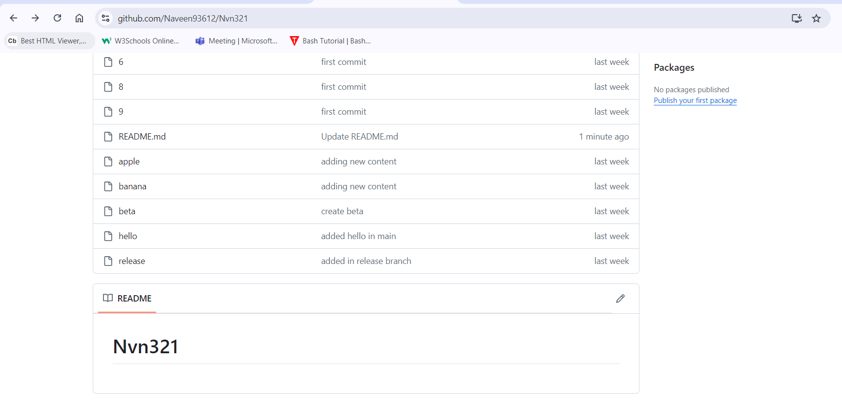

3)Clone the created repo to local.

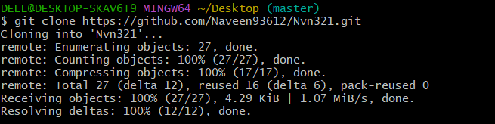

4)Create two files in local repo.



5)Commit two files and push to central Repository.

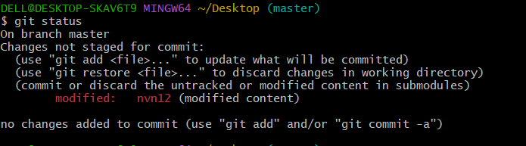

6)Create a branch in local and create a sample file and push to central.

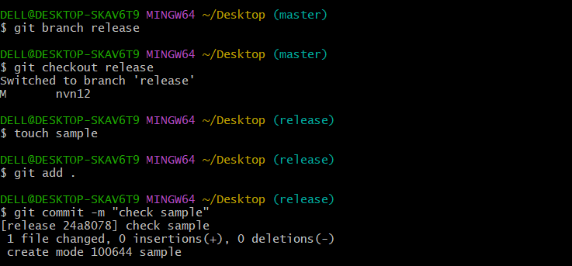

7)Create a branch in github and clone that to local.



8)Merge the created branch with master in git local.

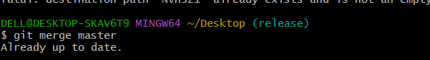

9)Merge the created branch with master in github by sending a pull request.

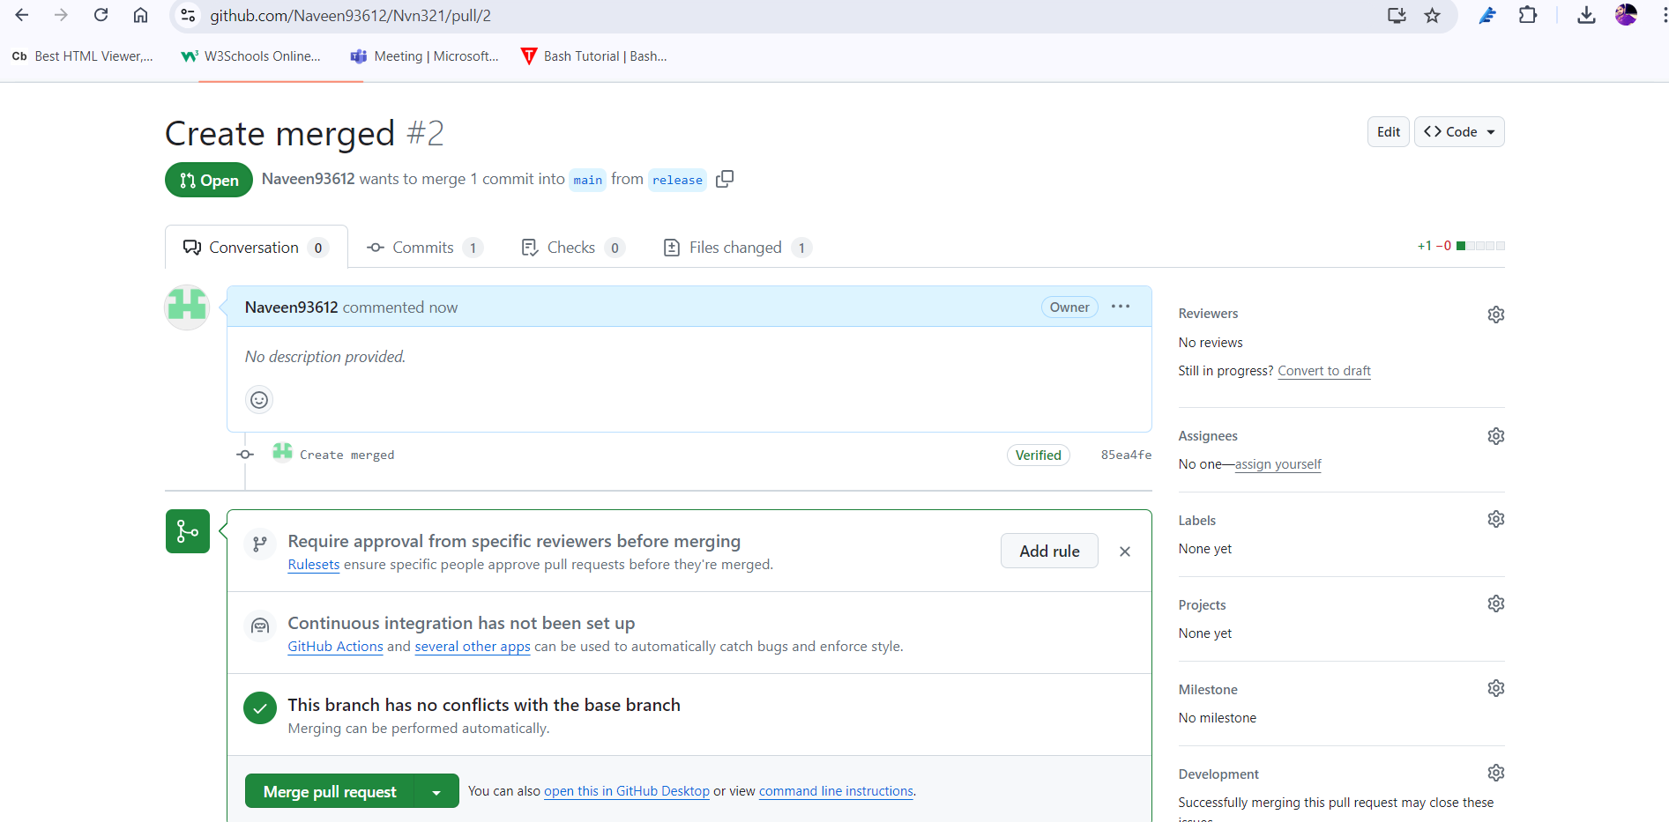

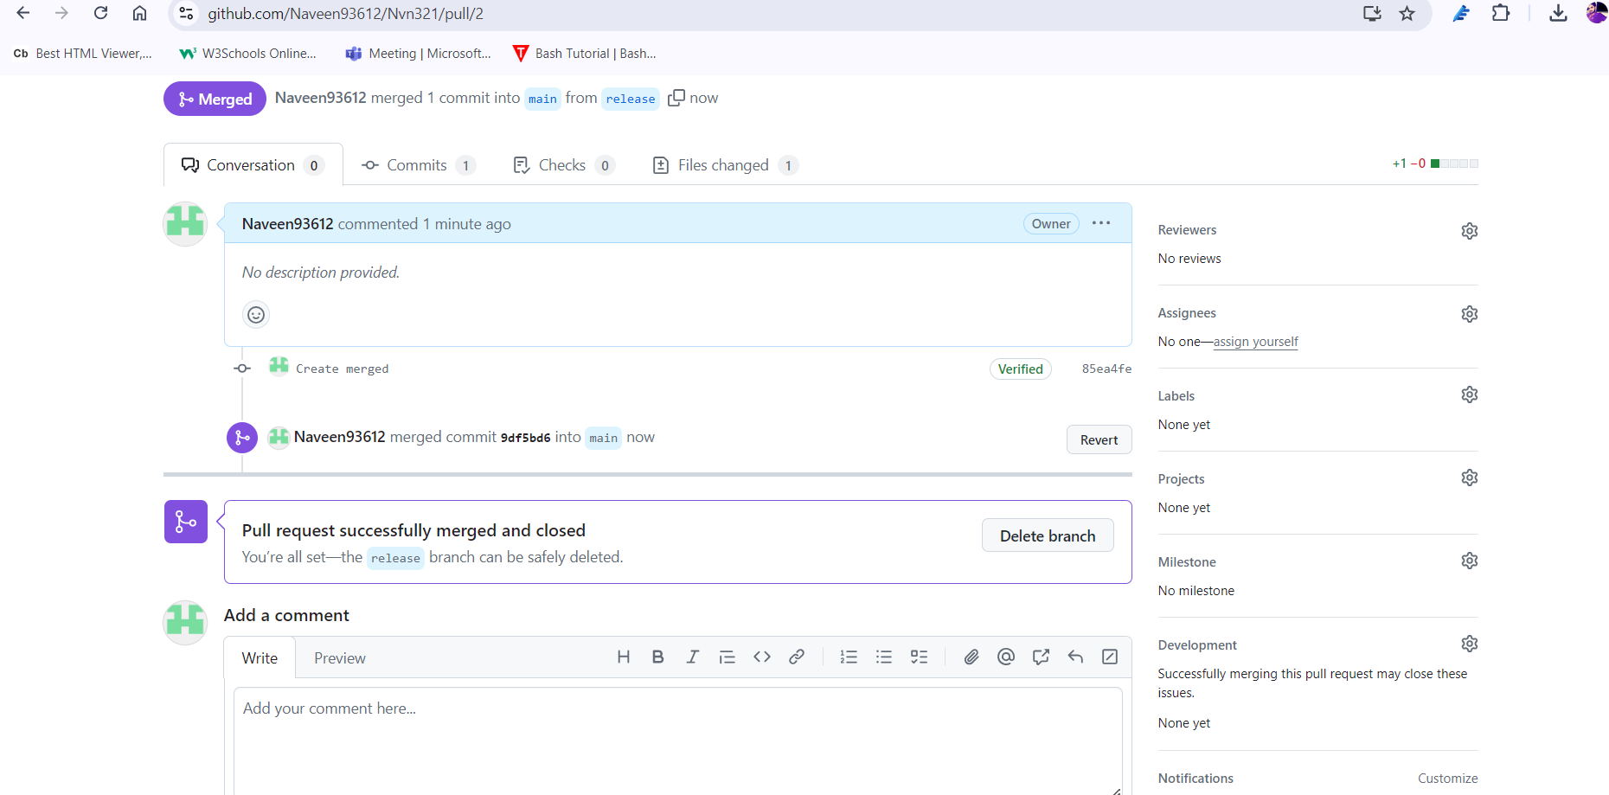

10)create a file in local and send that to branch in github.

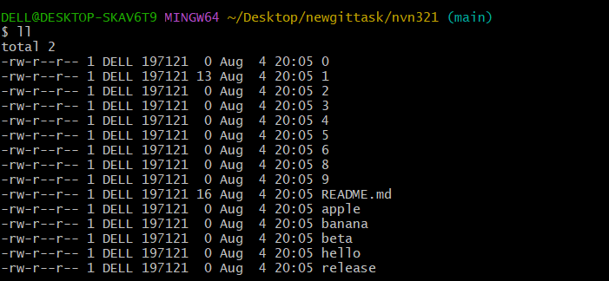

11)clone only a branch from github to local.

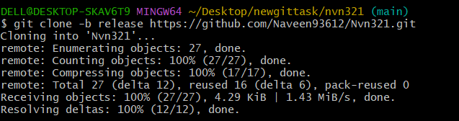

12)create a file with all passwords and make that untrackable with git.

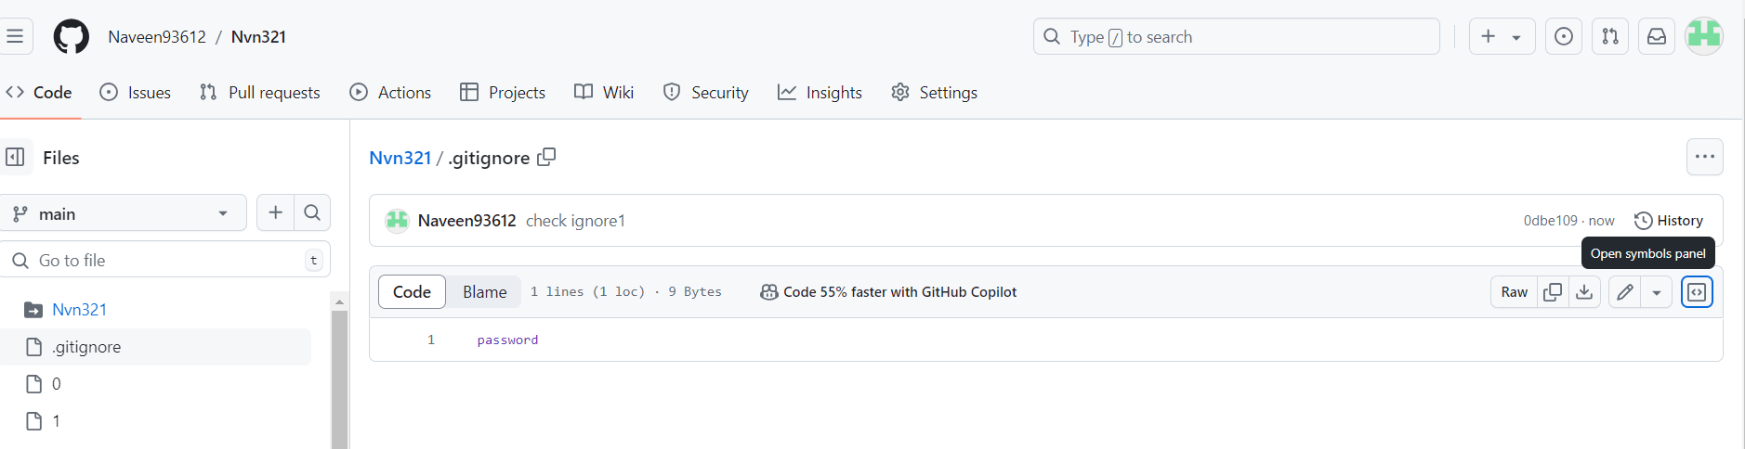

13)make a commit and make that commit reset without savings changes.



14)Revert a Commited commit to the older version.



15)push a file to stash without savings the changes and work on another file.

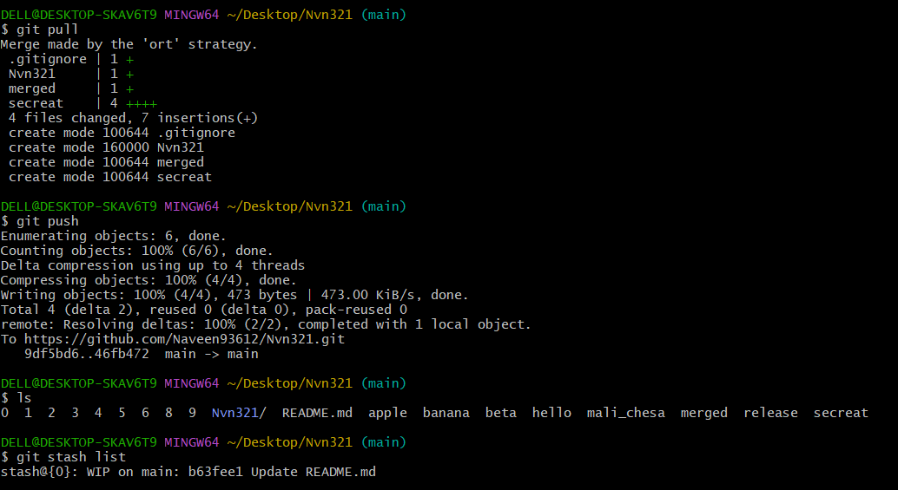

16)undo the stash file and start working on that again.

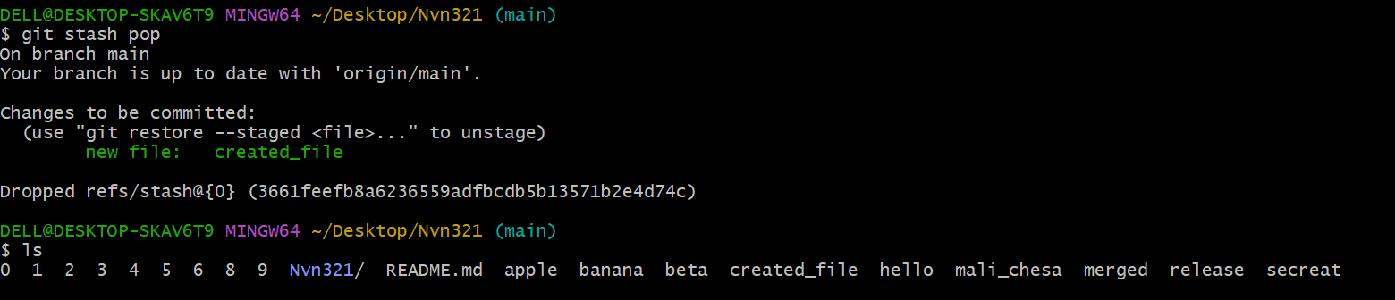

17)generate a ssh-keygen and configure into github.

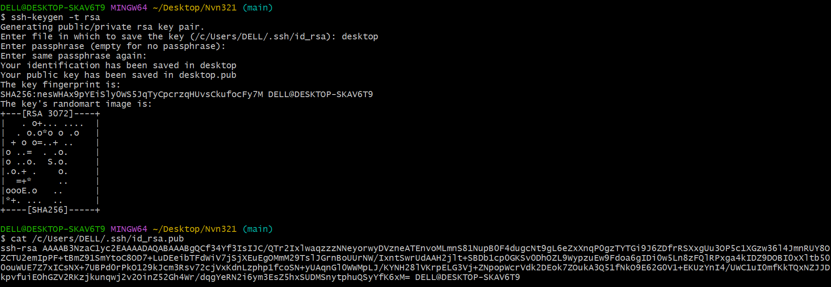

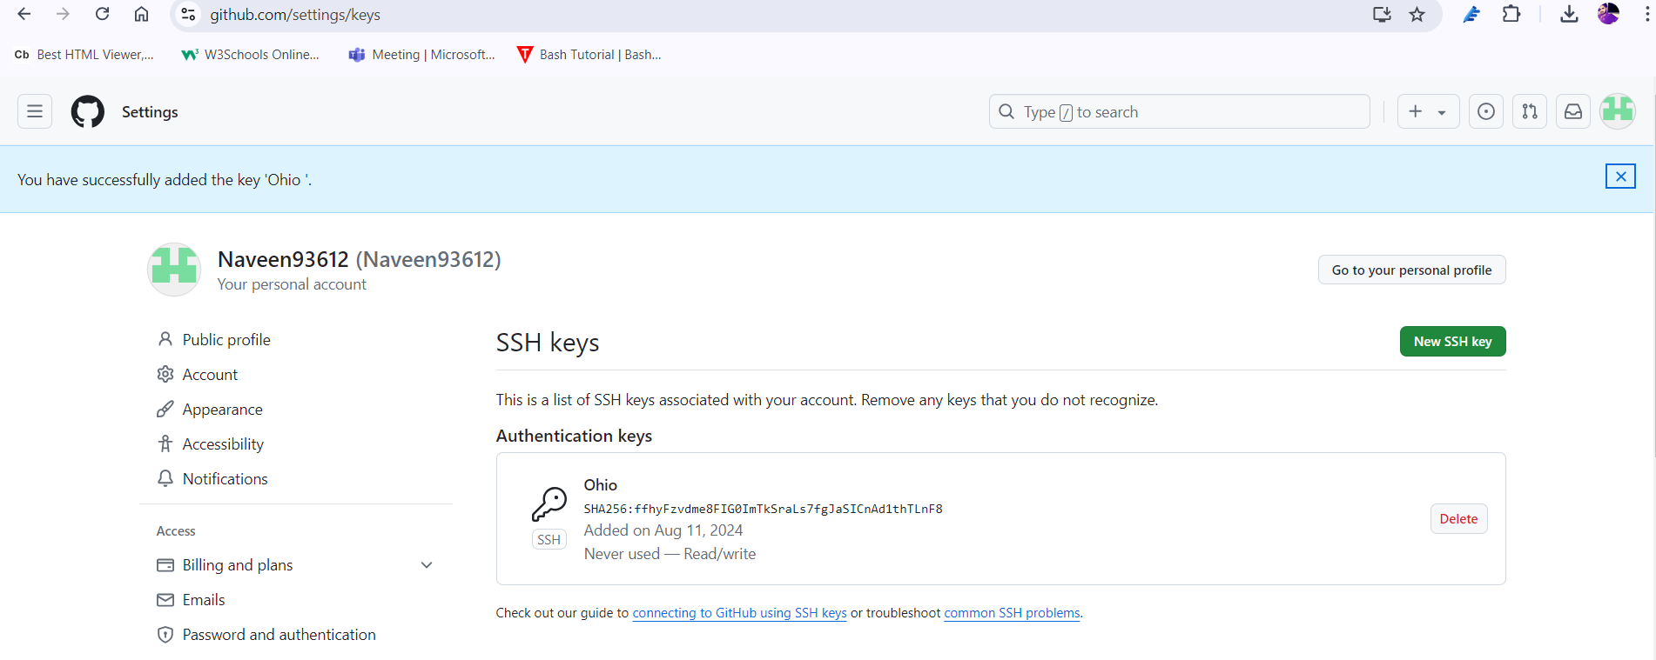

18)configure webhooks to github.

19)basic understanding of .git file.

* The .git directory is a hidden folder that stores all of Git's metadata and object database.
* It includes configuration files, hooks, references, and object storage essential for version control.
* Understanding the .git directory helps in comprehending how Git tracks and manages changes in a repository.

20)Check all the logs of git.

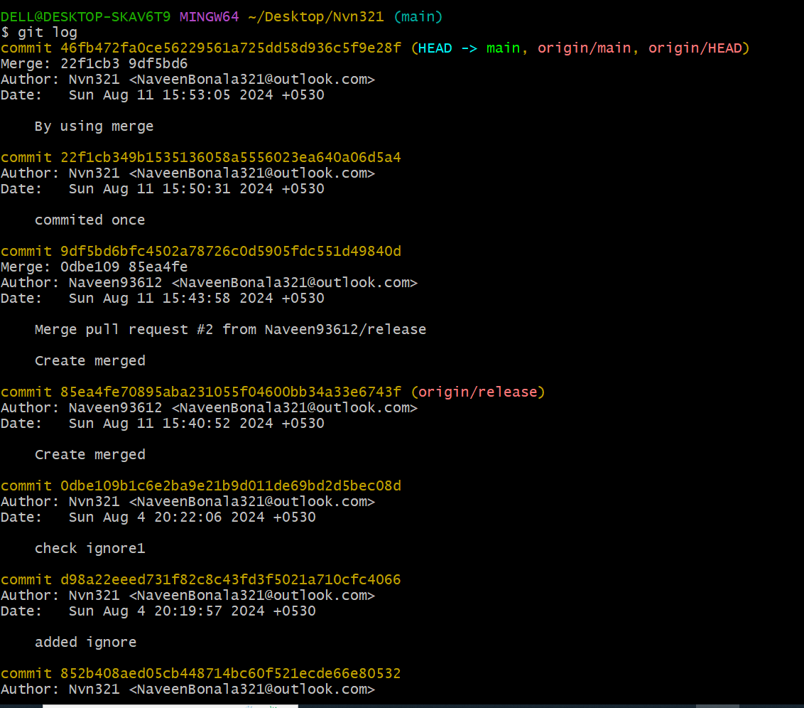

21)Rename the commit message.

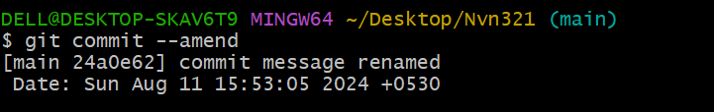

22)Merge multiple commits into single commit.

